|  |  |  |
| --- | --- | --- |
| **TakeHomeCase Case** |  |  |
| Web Programming | Description: LogoBINUS-University |
| **Periode Berlaku** Semester Genap 2022/2023  ***Valid on*** *Even Year 2022/2023* |  | **Software Laboratory Center**  **Assistant Recruitment 23-2** |

## Materi

*Material*

* Material A
* Material B

## Soal

*Case*

**TokoNJedia**

TokoNJedia is an Indonesia technology company with a mission to drive digital economic growth. TokoNJedia has significantly contributed to the Indonesian economy, bringing in 90% new micro-merchants. We go beyond the traditional merchant model, leveraging technological advancements to serve million of customers. TokoNJedia actively participates in shaping the future of the marketplace.

To keep up with the latest technological stack, TokoNJedia has decided to **migrate** to **Laravel** with **MySQL** to develop its website. As part of the development process, you must create this website and the **database** as follows :

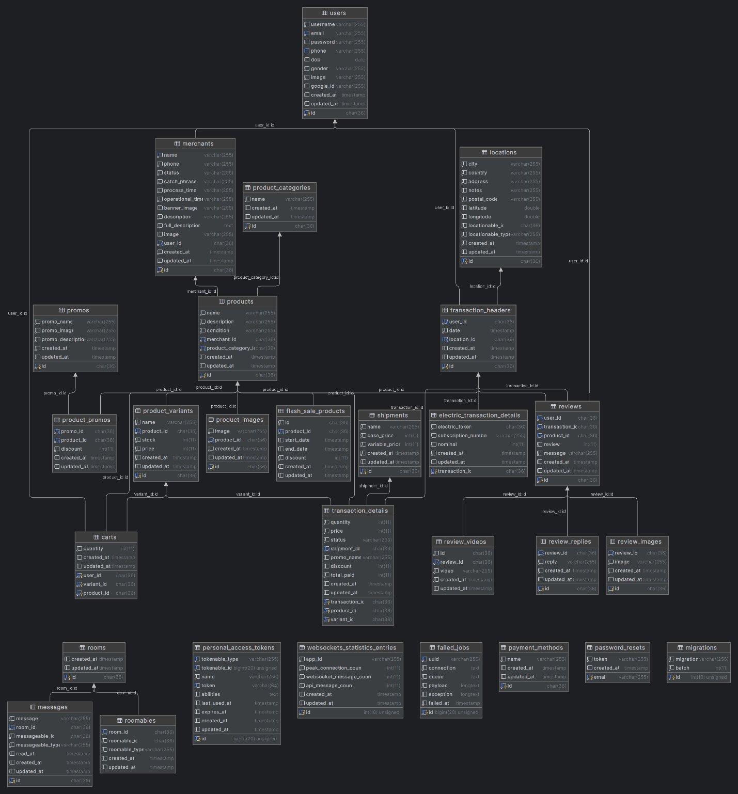

Figure 1. ERD

* **Migrations**
* **Seeding**
* Shipment

|  |  |  |
| --- | --- | --- |
| Shipment Name | Base Price | Variable Price |
| Regular | 10000 | 20000 |
| Next Day | 30000 | 50000 |
| Instant 3 Jam | 100000 | 500000 |
| Same Day | 50000 | 100000 |
| Cargo | 5000 | 10000 |

* Promo
* **Login Page**

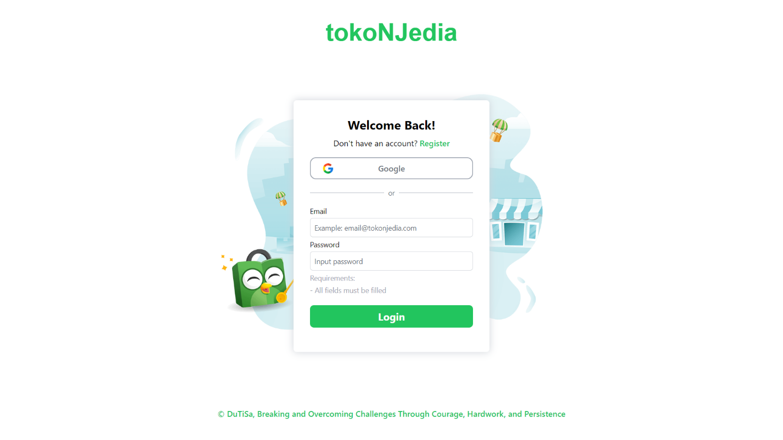

Figure 2. Login Page

* Only can be **accessed** by **guests**.
* Users can **log in** using **Google account** or by entering **their email and password**.
* Please use the "**Mandala**" **font** for the **title**.
* **Validate** that **all fields** must be **filled**.
* **Redirect** to the **home page** if the **login is** **successful**.
* **Register Page**

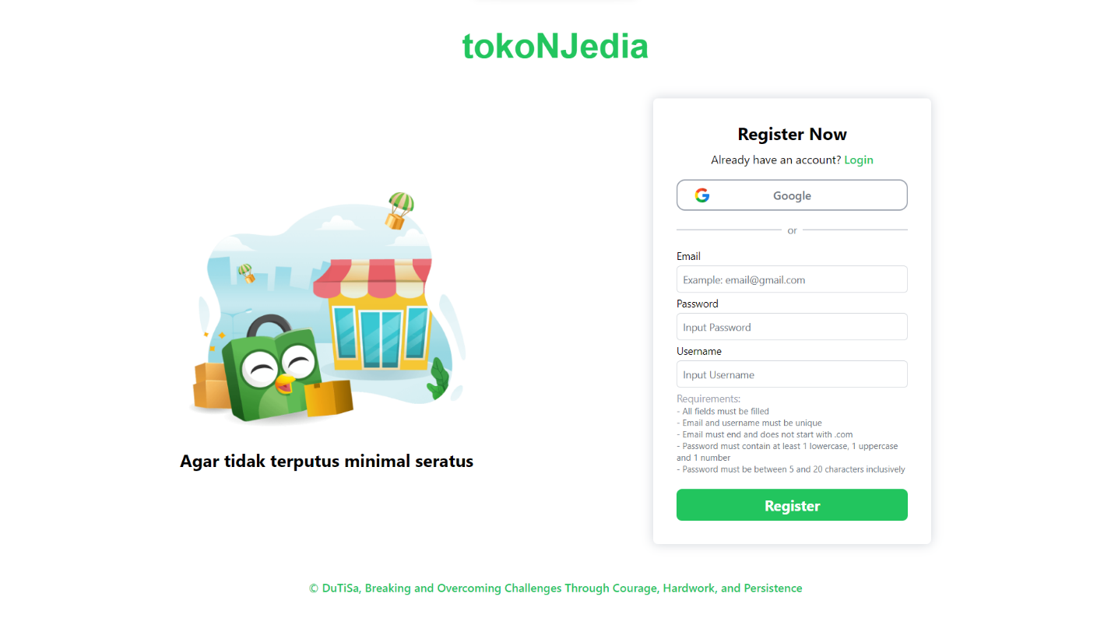

Figure 3. Register Page

* Only can be **accessed** by **guests**.
* Users can **register** using **Google** or by **providing their email**, **username**, and **password**.
* **Redirect** to the **login page** if the **registration** **is** **successful**.
* **Validate** **passwords** according to the following **requirements**:
* **All fields** must be **filled**.
* **Email** must be **unique**.
* **Email** must **end** with “**.com**”.
* **Email** should **not** **start** with “**.com**”.
* **Password** must **contain** at least **1 lowercase**, **1 uppercase**, and **1 number**.
* **Password** must be **between** **5 and 20 characters inclusively**.
* **Username** must be **unique**.
* **Registered** **user** will get a **default** **profile** **picture**.
* **Navigation Bar**
* Show an info section **with 5 links** that redirect to their **official pages**.
* Display **a logo** with the "**Mandala**" font that **redirects** users to the **home page**.
* Include a **search bar** that **redirects** users to the **search page**.
* Display **randomized** **word** as **recommendation keywords**.



Figure 4. Navigation Bar

* If the user is logged in:
* Display **Merchant** and **User** **button**.
* The **Merchant** **button** will **redirect** users to their **merchant dashboard**.
* The **User** **button** will redirect users to the profile page.
* The merchant button should show the profile picture of the merchant if user is not registered as a merchant yet show the default merchant logo.
* The merchant button should show the merchant store name.
* The profile button should show the profile picture of the user.
* The profile button should display the username of the user.
* If the user is logged in and not on the merchant page:
* Display the cart and chat buttons.
* Display a badge on the top right of the cart that shows how many items the user has in their cart, if any.



Figure 5. Navigation Bar (Guest)



Figure 6. Navigation Bar (Logged in user)



Figure 7. Navigation Bar (Merchant Page)

* **Footer**
* The footer will have links to the official page.
* Display a footer image, footnote, and copyright.



Figure 8. Footer

* **Home Page**
* Can be accessed by guests and users.
* Users and guests can see the Navigation Bar, Promo Product Banner, Top-up section, Product Recommendation, and Footer.
* Display available categories with one picture of the product.
* Show the Promo Product Banner using a Carousel. Redirect to the Promo Page if clicked.
* Only users can top up electricity in the Top-up & Bills section.
* Users can view their top-up history in the transaction history.
* For topping up electricity, validate:
* The Subscription number and nominal must be numeric.
* The subscription number must be between 11 and 12 digits.
* Nominal must be between 10,000 and 1,000,000.

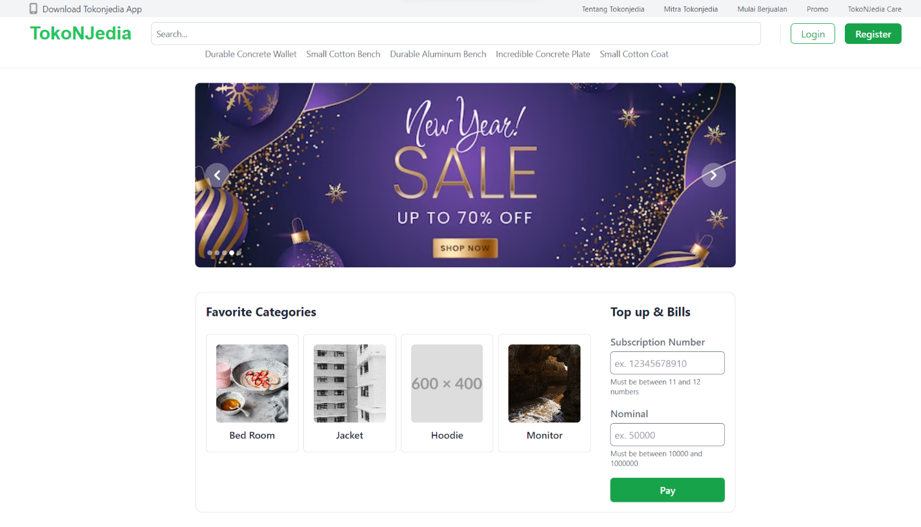

Figure 9. Home Page

* **Flash Sale**

Flash sale is a discounct that is limited for a specific time frame.

* Flash Sale discounts are available every day from 10 p.m. until 12 A.M for 5 products.
* Display a countdown until the flash sale starts with a grayed-out background or a countdown until the flash sale ends.
* Show cards for discounted products.

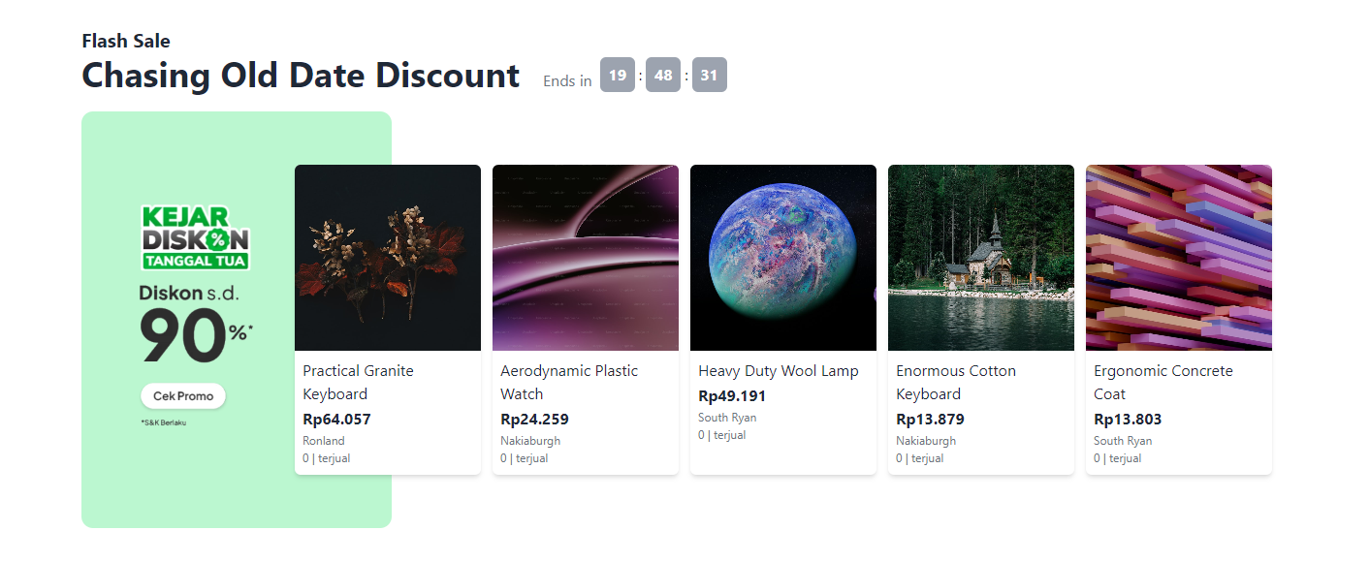

Figure 10. Flash Sale

* **Recommendation Products**
* Randomize products to show in product cards.
* Each card must have all the necessary components:
* Product Image
* Product Name.
* Product Merchant Name
* Product Merchant City.
* Product Price.
* Product Sold.
* Display a loading skeleton before loading the images.
* Implement Infinite Scrolling to show more randomized products.
* Redirect users to the product detail page if clicked.

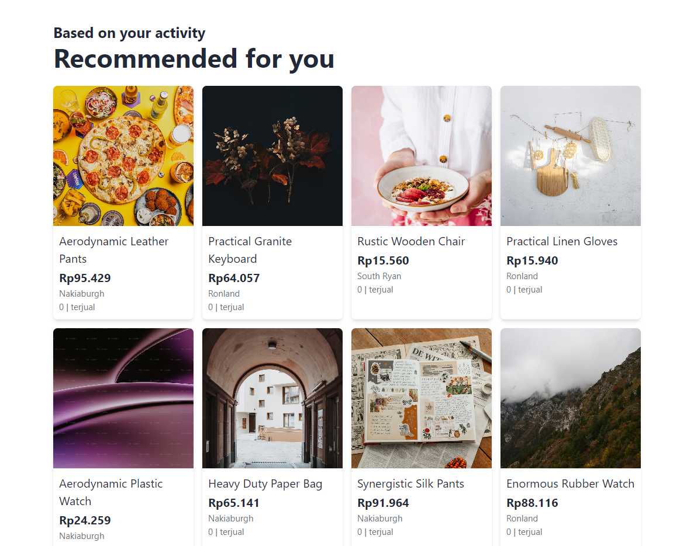

Figure 11. Recommendation Products

* **Product Detail Page**
* Can be accessed by guests and users.
* Show product details:
* Product Image in Product Image View.
* Product Name.
* Product Sold.
* Product Average Rating.
* Product Rating Count.
* Product Price.
* Product Condition.
* Product Description.
* Product Merchant.
* Product Variants.
* Adding to Cart Section.
* Reviews.
* Product Recommendations.

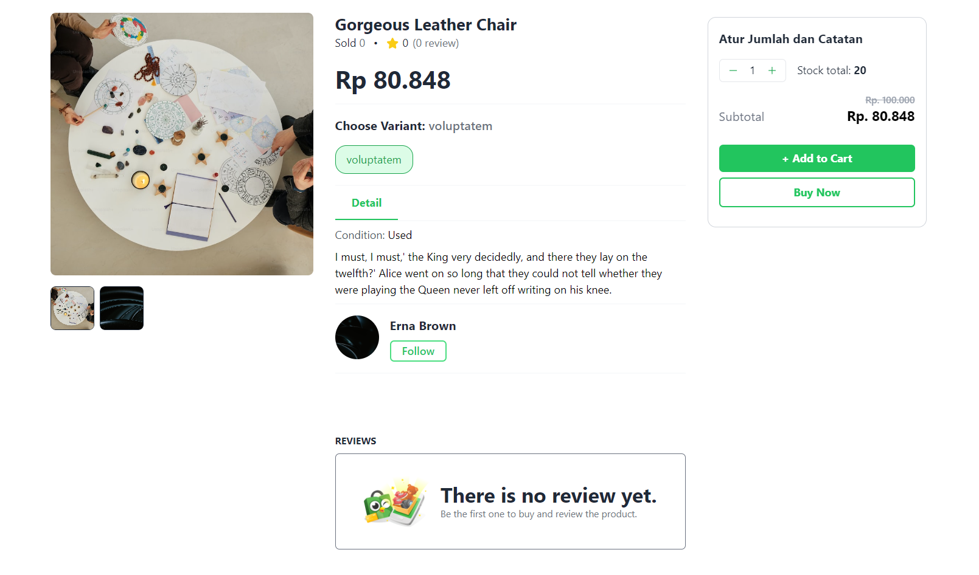

Figure 12. Product Detail Page

* Product Image View must change on hover.
* Product Variant options can be chosen.
* Product Price and Stock will change depending on the variant chosen.
* Product Merchant must show the merchant profile image, merchant name, and follow button.
* The Follow button will add the merchant to the user's following list.
* Reviews must show 6 customer photos and videos from random reviews.
* Reviews must display:
* Star rating.
* Time since published.
* Reviewer profile page.
* Reviewer name.
* Reviewer photos or videos.
* Replies

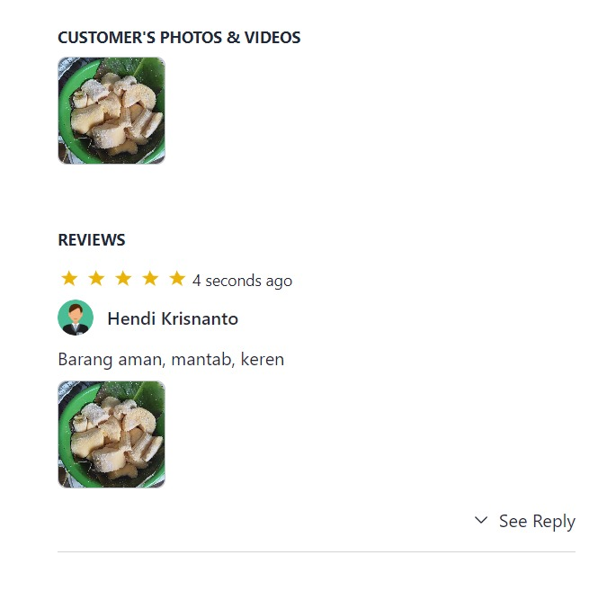

Figure 13. Review

* Only the merchant can reply to customer reviews (the button will only appear for the seller).
* Show a button to toggle opening the reply section of customer reviews if the review has any replies.
* Adding to Cart must display:
* Quantity Chooser.
* Subtotal.
* Add to Cart button.
* Product Stock.
* Buy now button.
* The Quantity Chooser will have buttons to reduce or add quantities.
* Validate the chooser cannot exceed the product’s stock or be lower than 1.
* Only logged-in users can add items to the cart or buy the product; if not, redirect the user to the login page.
* If the user clicks the Add to Cart button, add the item to the cart and show a success modal with the item name, a button to go to the cart page, and a randomized product for recommendation.
* If the user clicks the Buy Now button, add the item to the cart, then proceed to checkout all items in the cart to the Shipment Page.

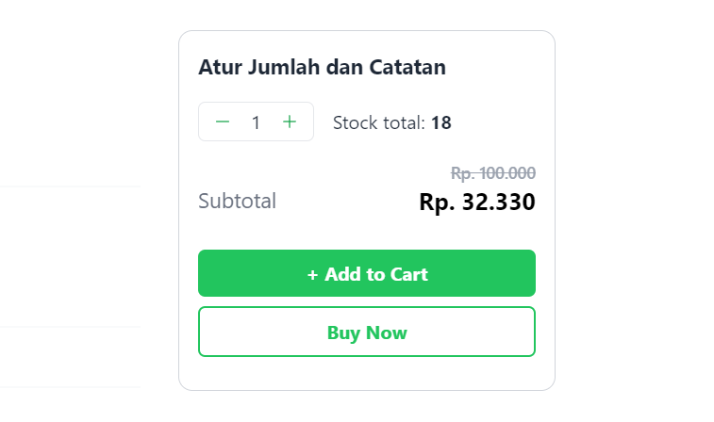

Figure 14. Buy Now or Add to Cart

* Show randomized product recommendations with infinite scrolling.
* **Cart Page**
* Logged-in users can access the cart page to view their items in the cart.
* If the user does not have anything in their cart, display the information notice.

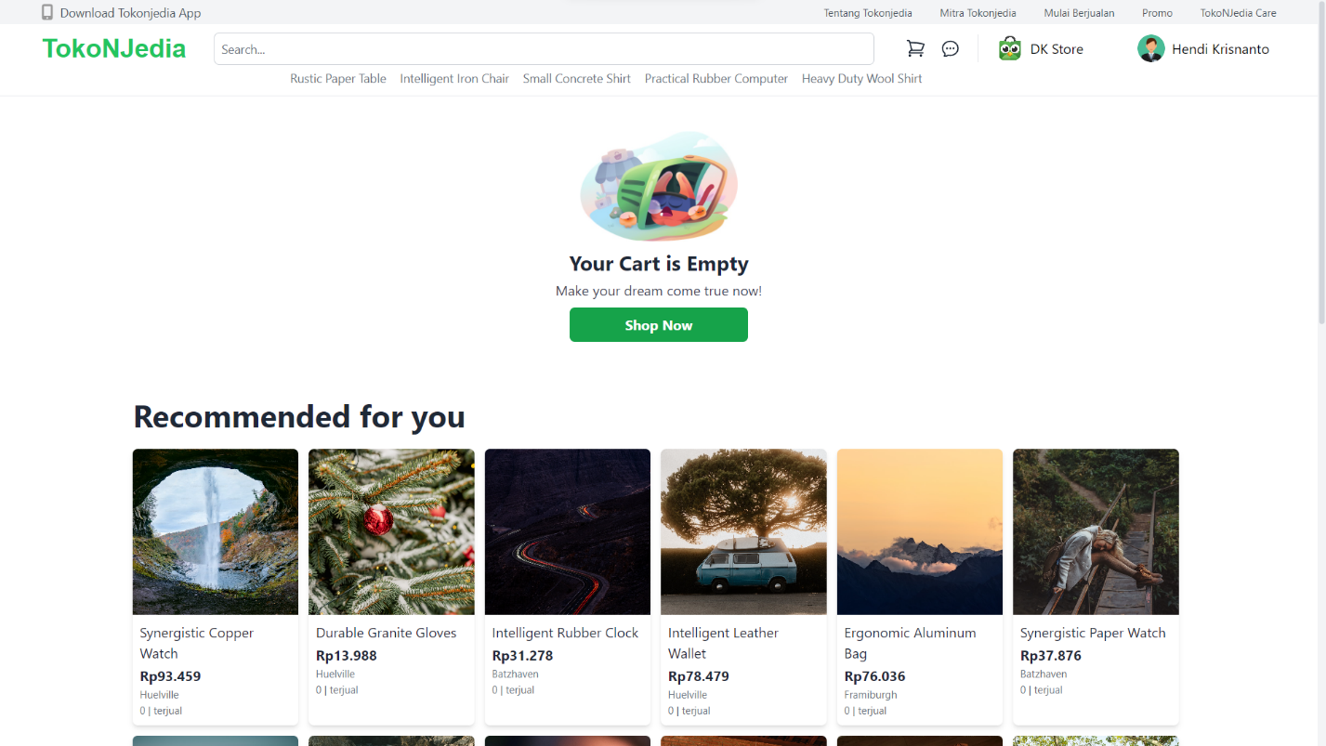

Figure 15. Empty Cart

* The cart page must display:
  + Cart items
  + Shopping Summary
  + Product Recommendations



Figure 15. Empty Cart

* Items in the cart must display:
  + Merchant Name
  + Merchant City
  + Product Image
  + Product Name
  + Product Variant Price
  + Delete Button
  + Edit Quantity Chooser
* Users can delete items in their cart using the delete button.
* Users can change the quantity of the item in the cart using the minus or add button, and this update must also be reflected in the database.
* Validate that the quantity cannot exceed the item stock and is not less than 1.
* The Shopping Summary must display:
  + Total price of all items in the cart.
  + Grand total (Total price of all items in the cart with their discount).
  + Buy button to redirect the user to the cart page.

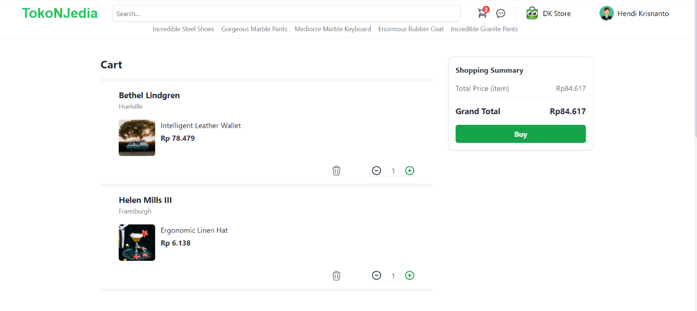

Figure 16. Cart with items

* Show randomized product recommendations with infinite scrolling.
* **Shipment Page**
* Users with items in their cart can access the shipment page to check out all items in their cart.
* The shipment page must display:
  + Shipping address
  + Item detail
  + Subtotal
  + Shipping Receipt head and foot
  + Shopping Summary

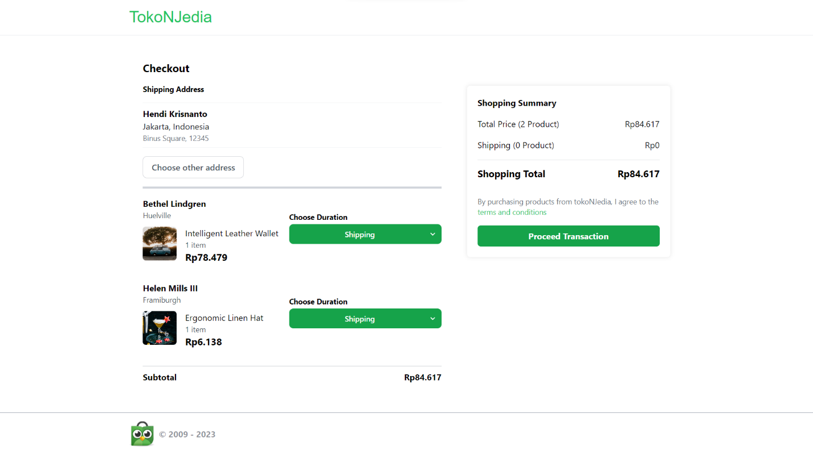

Figure 17. Shipment Page

* Users can choose their desired address via a modal that lists all addresses the user has registered.
* For all registered locations, the modal must display:
  + Username
  + City
  + Country
  + Address
  + Postal Code

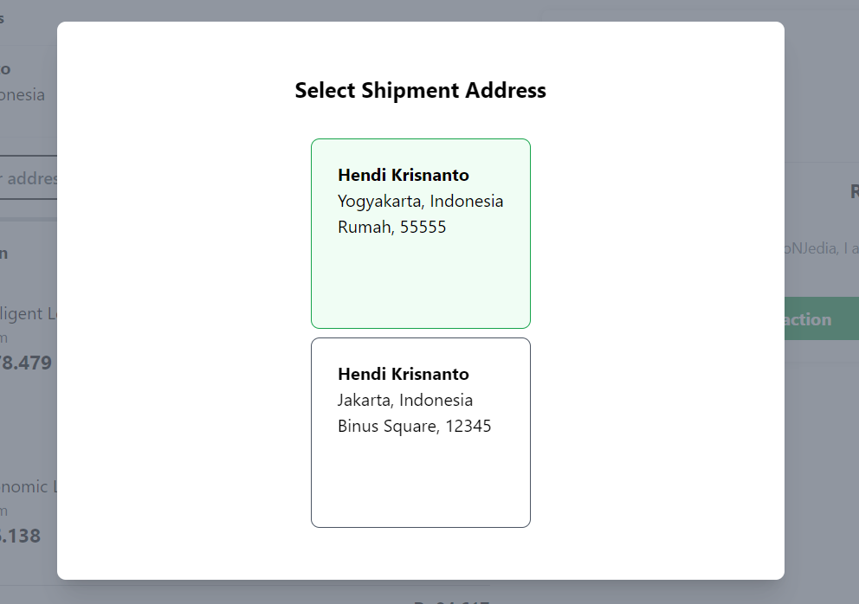

Figure 18. Locations Modal

* Users can choose the shipping duration for each item on the page that has been created.
* To calculate the shipment price, use this formula:

Price = Shipment Base Price + (Distance in KM * Shipment Variable Price / 1000)

* Display the shipment price for each item by calculating the distance of the merchant latitude and longitude using the Haversine Formula.

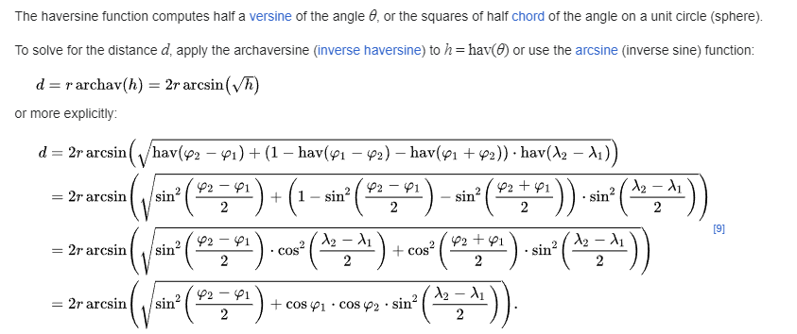

Figure 19. Haversine Formula

* If the user chooses another location as their desired address, all the shipping prices will be recalculated and updated.
* The Shopping Summary consists of:
  + Total price of the product
  + Total price of the shipment
  + Shopping Total (Final total for all the shipment and product)
  + Proceed Transaction Button
* The Proceed Transaction button will create the transaction for all items in the carts and clear the user's carts.
* For proceeding with the transaction, the system must validate that the shipment is filled for all items.
* If successful, redirect the user to the transactions page.
* **Search Page**
* All users can access the search page.
* View all products that contain any word from the search query.
* Filter items for products and stores.
* **Search Page – Product Tab**
* If product is not found display:
  + Error image.
  + Error message.
  + Button to redirect back to home.
  + Recommended products.

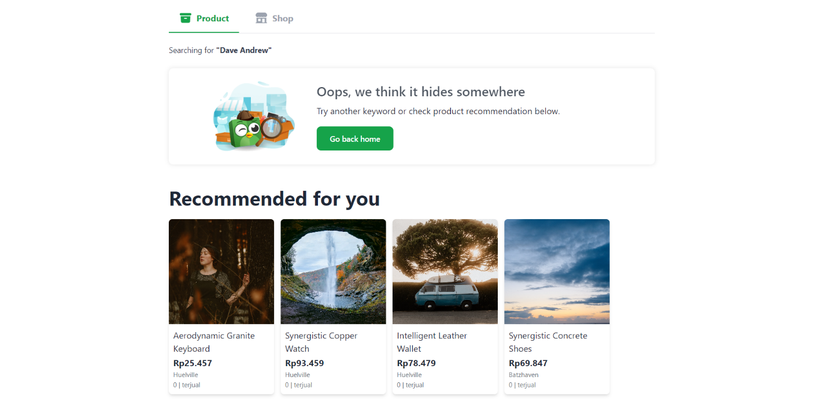

Figure 20. Product Not Found

* The Product Section consists of:
  + Merchant highlight if there is any merchant name that contains any word from the search engine.
  + Product results from the search query.
* Products must be shown in the product card format.
* Paginate the products.

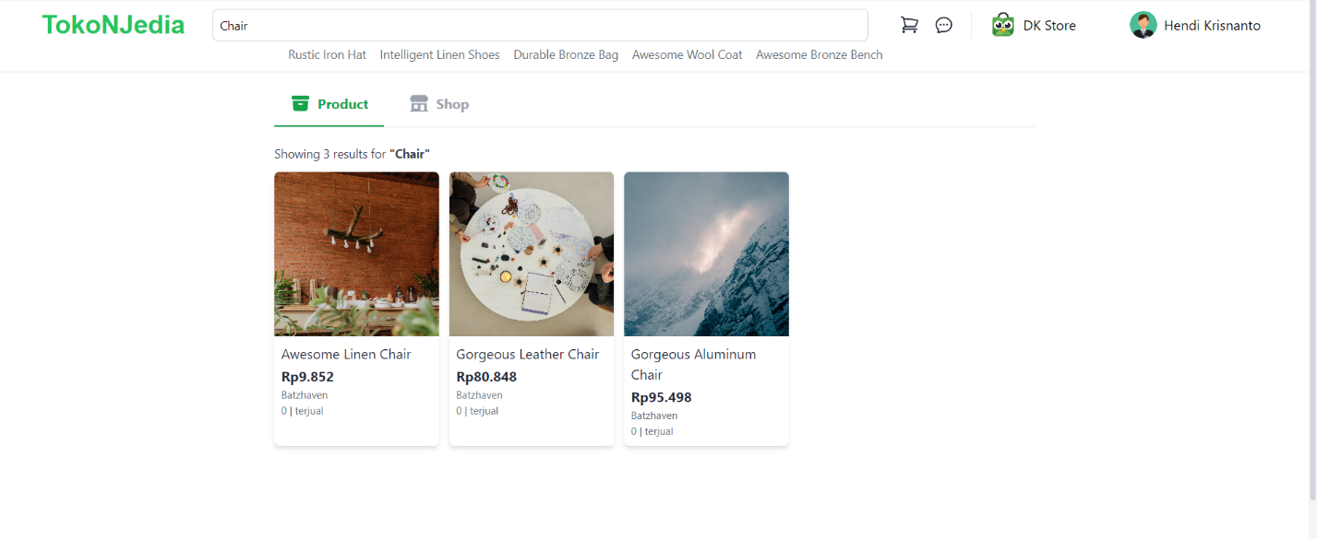

Figure 21. Search Page (Product Tab)

* At the bottom, show recommended products even if no product is found.
* The product in the merchant highlight can be clicked to redirect the user to the product detail.
* If the merchant highlight is clicked, redirect the user to the merchant page.
* If the "See Another Products" button is clicked, redirect the user to the merchant’s product page.

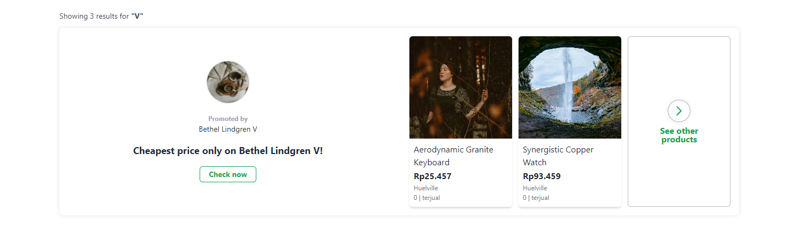

Figure 22. Merchant Highlight

* **Search Page – Merchant Tab**
* Merchant highlights must contain product highlights from the merchant.
* The Merchant section consists of:
  + Merchant results from the search query.
  + 3 product highlights from the merchant.
* If the merchant is clicked, redirects the user to the merchant homepage.
* If the highlighted product is clicked, redirect the user to the product detail.
* If there is no merchant found, display:
  + Error image
  + Error name
* Paginate the merchants.
* Merchant must be shown in the merchant card format.
* At the bottom, show recommended products even if no merchant is found.

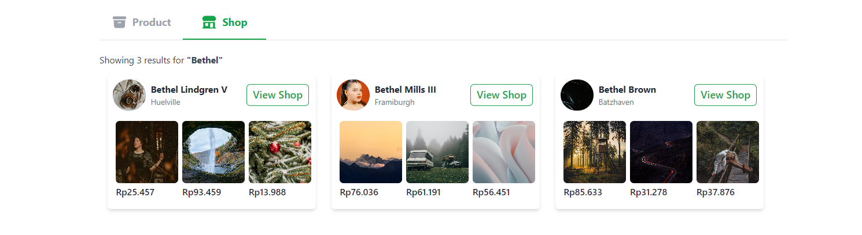

Figure 22. Search Page (Merchant Tab)

* **Profile Page**
* Logged-in users can access profile pages.
* Profile page consists of some pages:
  + General
  + Location
  + History Transaction
  + Wishlist
  + Favorite Store
* It gives the user the option to log out.

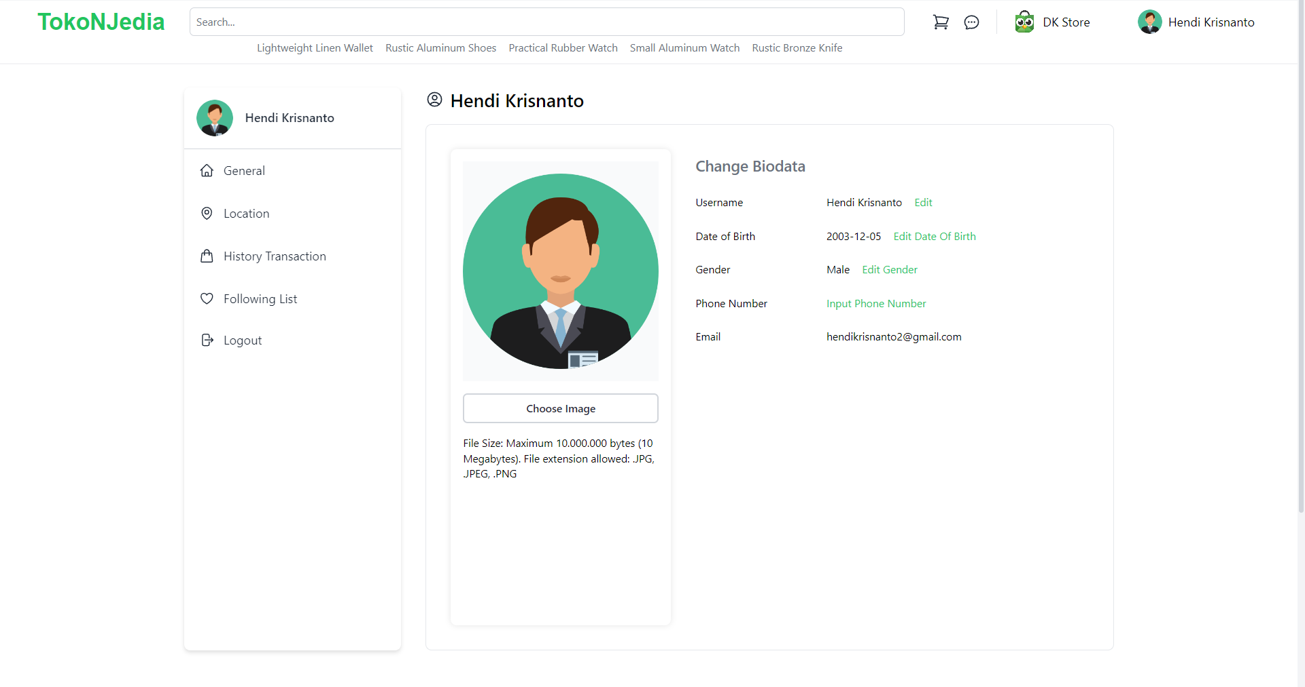

Figure 23. Profile Page

* **General Page**
* General Page consists of:
  + Profile Picture Image
  + Username
  + Date of Birth
  + Gender
  + Phone Number
  + Email
* Profile picture can be updated with validation:
  + File Size: Maximum 10,000,000 bytes (10 Megabytes).
  + File extension allowed: .JPG, .JPEG, .PNG
* Usernames can be updated by showing the edit username modal.
* Username validation:
  + Must be filled.
  + Username must be between 3 and 20 characters.
  + Username must be unique.

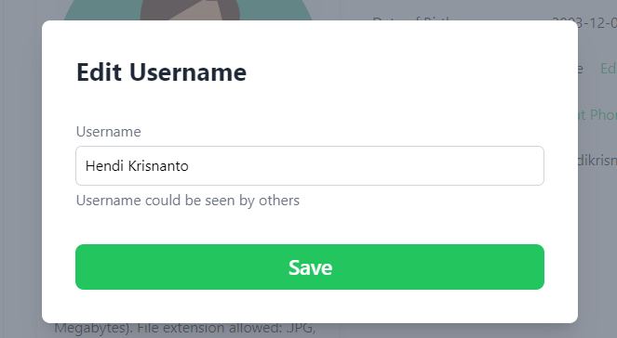

Figure 24. Edit Username Modal

* Date of Birth can be updated by showing the insert date of birth modal.
* Date of Birth validation:
  + Must be filled.
  + Between 1 January 1970 and the current date.

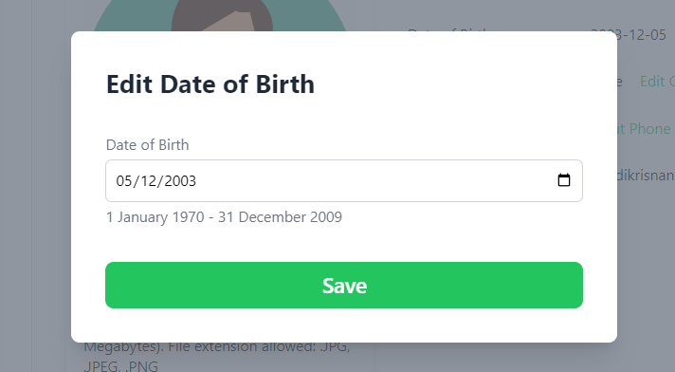

Figure 25. Edit Date of Birth Modal

* Gender can be updated by showing the update gender modal.
* Selected gender must be highlighted first.
* Gender options are Male, Female, Others.

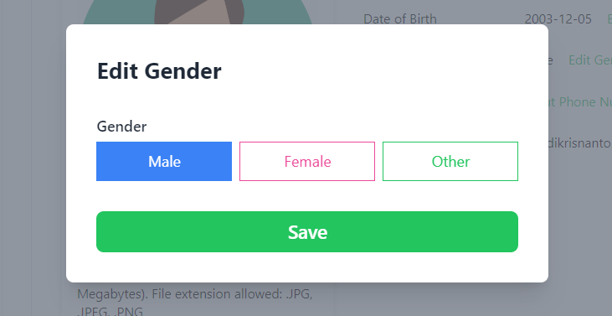

Figure 26. Edit Gender Modal

* User’s phone number can be updated by showing the update phone number modal.
* Phone number validation:
  + Must be filled.
  + Must be numeric.
  + Must be exactly 12 digits.

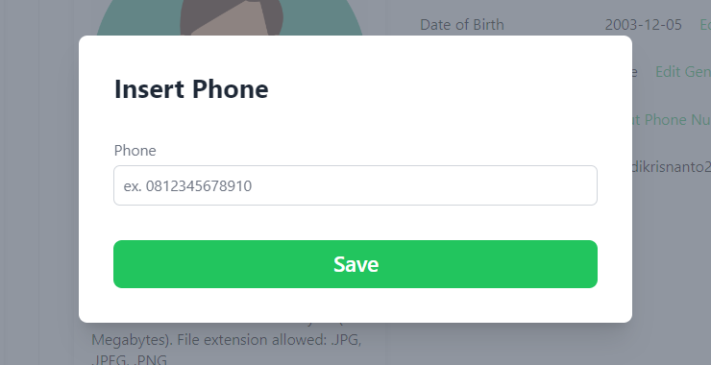

Figure 27. Edit Phone Number Modal

* **Location Page**
* Users can view their list of locations on the location page.
* If the user has no location yet, display the error information with the corresponding image.
* Show all user’s registered locations and a button to add a location.
* Each location must be displayed with:
  + Name
  + City
  + Country
  + Address
  + Delete Button
* Users can delete a location by using the delete button.
* The "Add Location" button will open the location modal.

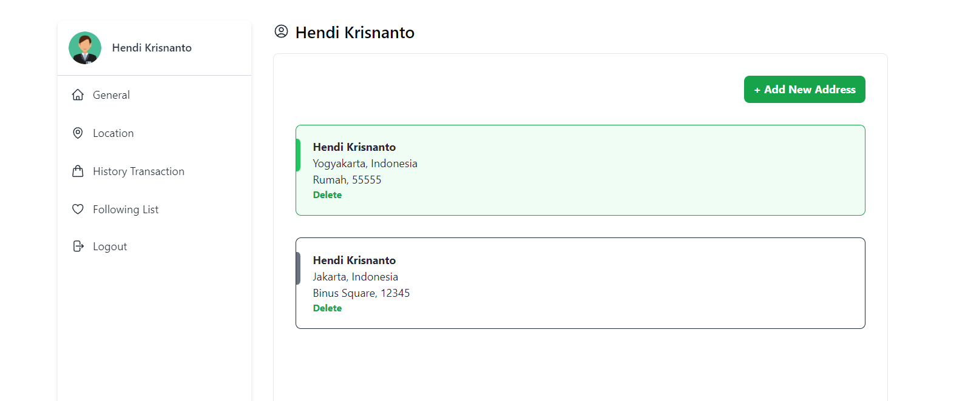

Figure 28. Location Page

* **Location Modal**
* The Location modal consists of two steps:
  + Pinpoint location
  + Complete Address detail
* **Pinpoint Location**
* This step will load and show a map view from the Google Maps API.
* The map should be anchored to the user’s current location.
* Display the current user’s Latitude and Longitude.

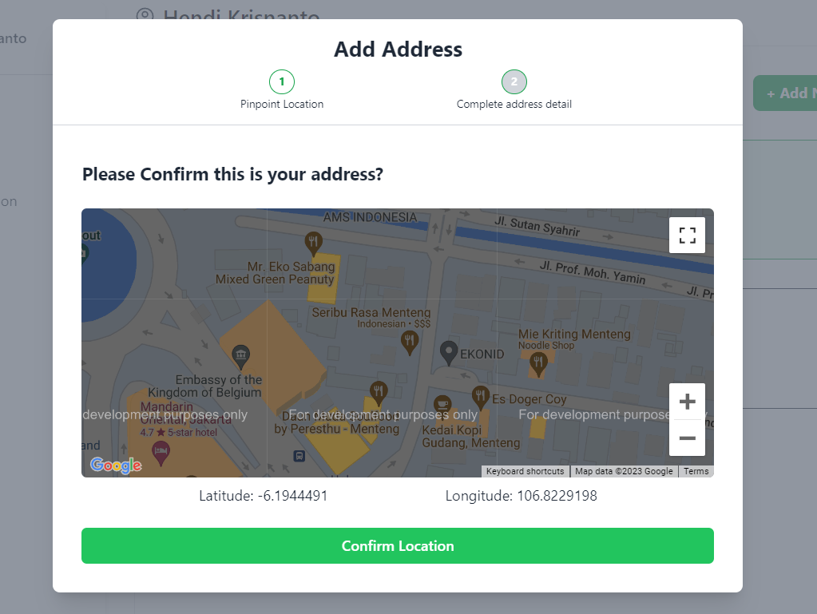

Figure 29. Step 1: Pinpoint Location

* **Complete Address Detail**
* This section displays a form to complete the address.
* The address form consists of:
  + Address
  + City
  + Country
  + Postal Code
  + Notes
* To add location, validate:
  + All fields must be filled.
  + Postal code must be numeric.
  + Postal code must be 5 digits.

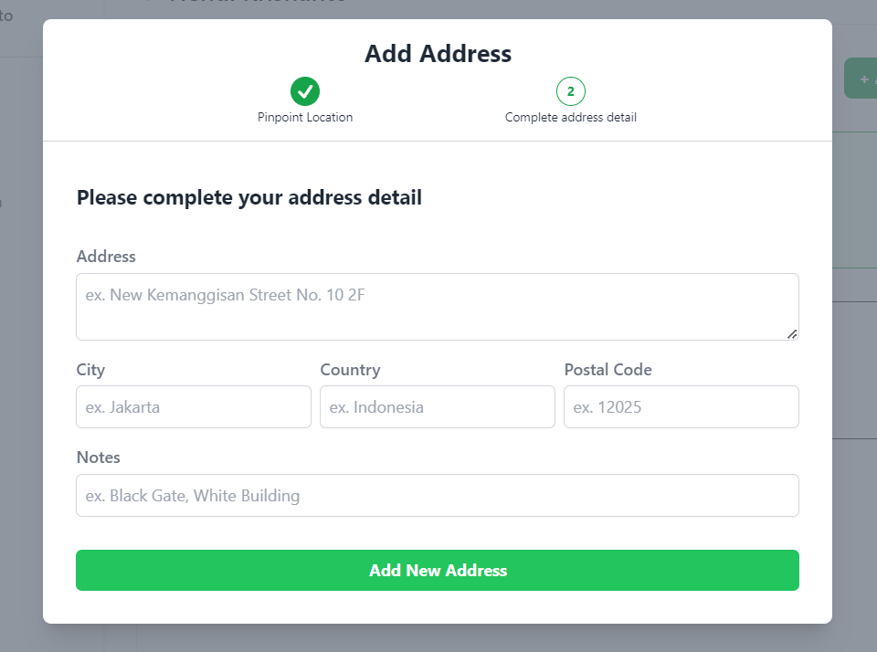

Figure 30. Step 2: Complete Address Detail

* **Transaction Page**
* **Users** can view their past transactions on the transaction page.
* Show product details for user history transaction.
* If the user has not done any transaction yet, show error display with image from
* Transaction must consist of:
  + Transaction category (Shopping or Top up & Billing)
  + Transaction Date
  + Transaction Status
  + Transaction ID
  + Product Name
  + Product Image
  + Product Variant (if any)
  + Quantity (if any)
  + Variant Price
  + Electric token (if any)
  + Total Price
  + Button set.
* Paginate the transactions, showing 5 items per page.
* Show a button set according to the transaction status.
  + Pending: Chat Seller Button
  + Shipping: Confirm Received Button
  + Completed: Give Reviews and Buy Again Button
  + Rejected: -
  + No Status: -
* Top up and bill transactions do not have a transaction status, therefore action buttons will not be displayed.
* The Chat Seller button will redirect the user to the chat room with the seller if any. If there is no chat yet, create a new one.
* The Confirm Received button will update the transaction status from “Shipping” to “Completed”.
* Authorize that the user has not yet reviewed the transaction before showing the Give Reviews button.
* The Give Review button will redirect users to the add review page.
* The Buy Again button will redirect users to the product detail page.

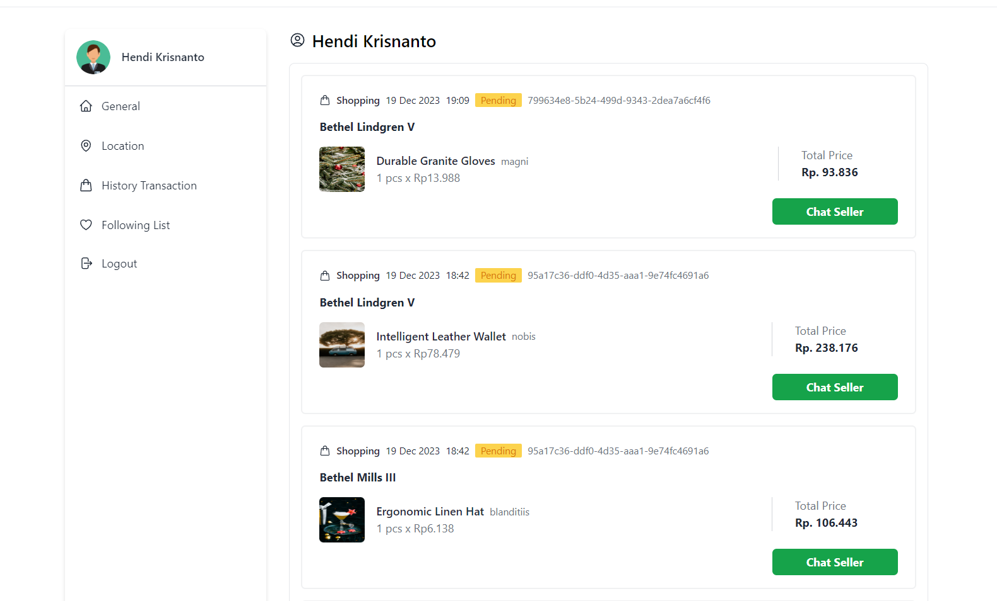

Figure 31. Transaction Page

* **Transaction Status**
* Transaction Status consists of:
  + Pending
  + Shipping
  + Completed
  + Rejected
* **Transaction status starts with Pending.**
* The merchant confirming the transaction will update the status to Shipping.
* The user confirming shipping will update the status to Completed.
* User rejecting shipping will update the status to Rejected.
* Here is the diagram flow for the transactions:

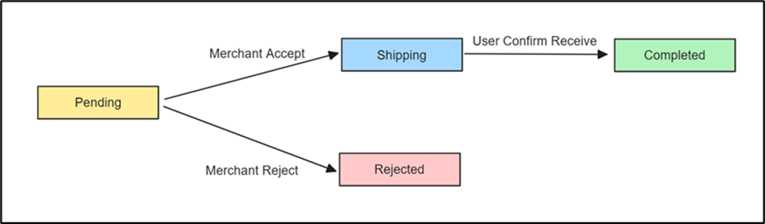

Figure 32. Transaction Flow

* **Add Review Page**
* The Add Review Page can only be accessed if the transaction of the product is not reviewed yet (If the user has bought the same item in a new transaction, then the user can add a new review).
* The Add Review Page consists of:
  + Product Image
  + Transaction Date
  + Variant Bought
  + Product Store
  + Star Rating
  + Upload Image input
  + Upload Video input
  + Message input
  + Insert Review button
* Users can give ratings by either hovering over stars and selecting the desired rating or by clicking on the stars to choose a rating.
* The chosen star rating will be highlighted in yellow.
* The Upload image field is used to input images as an image review.
* The Upload video field is used to input videos as a video review.
* The Message field is used to input a review message for the item review.
* To insert a review, validate:
  + Message field must be filled.
  + If any of the image fields is filled, make sure the extensions are JPG, PNG, or JPEG.
  + If any of the video fields is filled, make sure the extensions are MP4 or MOV.
* After the Insert Review button is clicked, save the review to the database.

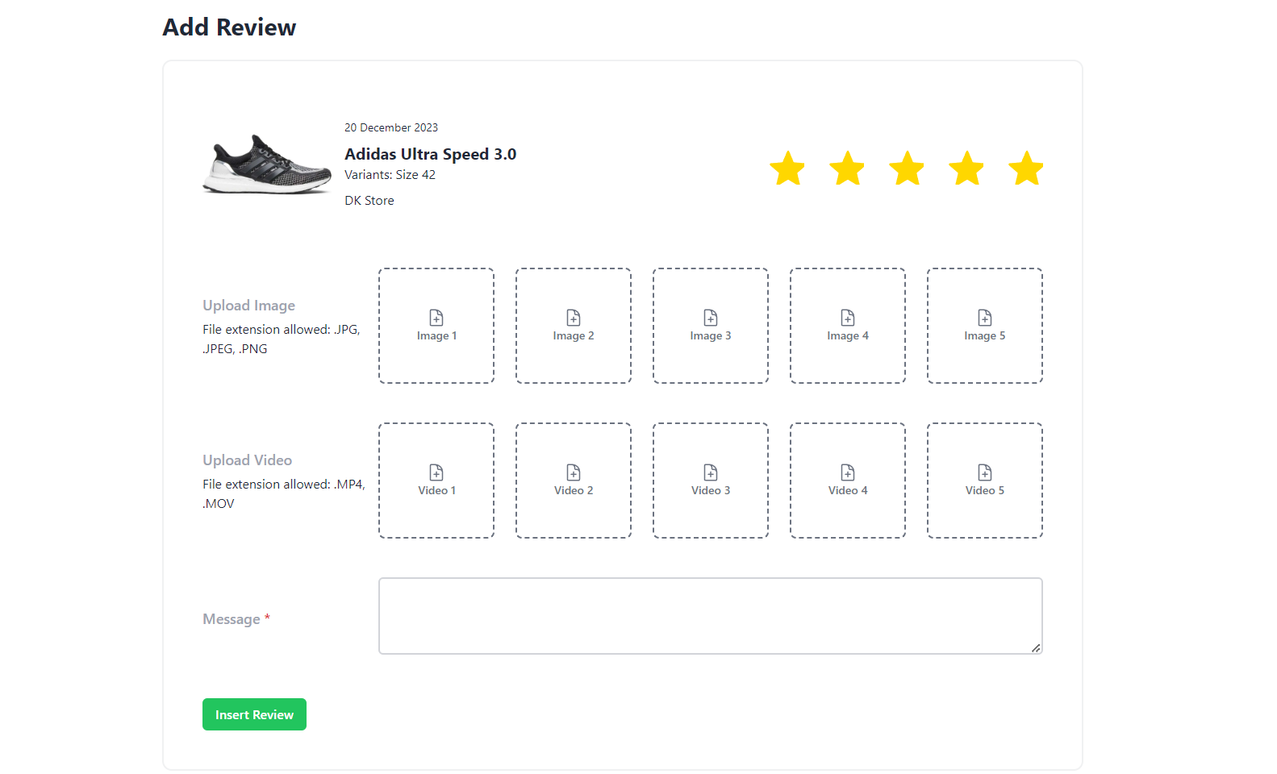

Figure 33. Add Review Page

* **Merchant Create Page**
* Users that have not registered yet as a merchant can access this page to create a new merchant.
* Display registration benefits (Image and subtitle)
* Display merchant form in three steps with back and next button:
  + Phone Number
  + Merchant Name
  + Location
* In phone number step, display fields to input user phone

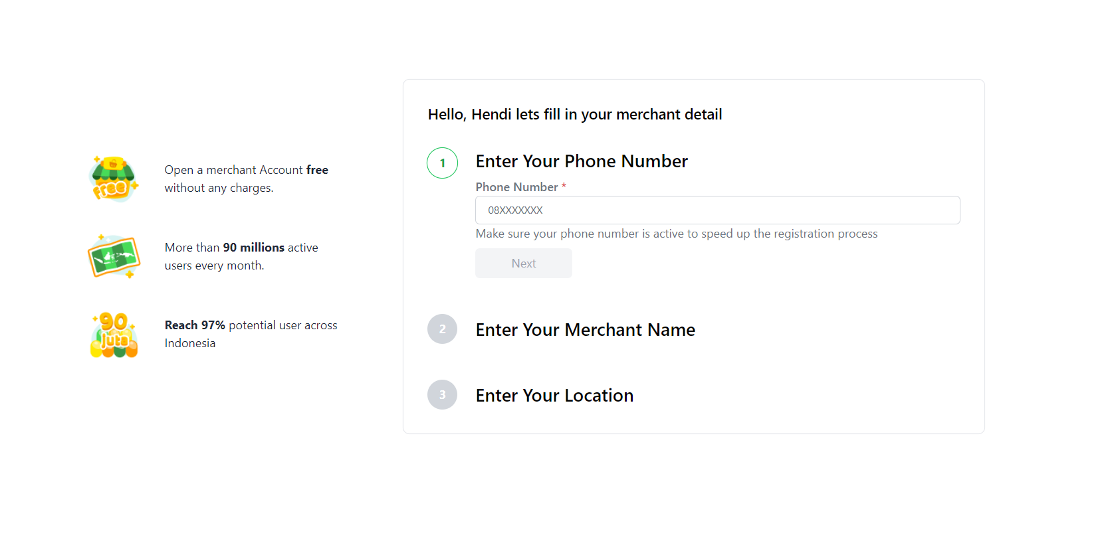

Figure 34. Create Merchant (1)

* In merchant name step, display fields to input merchant name.

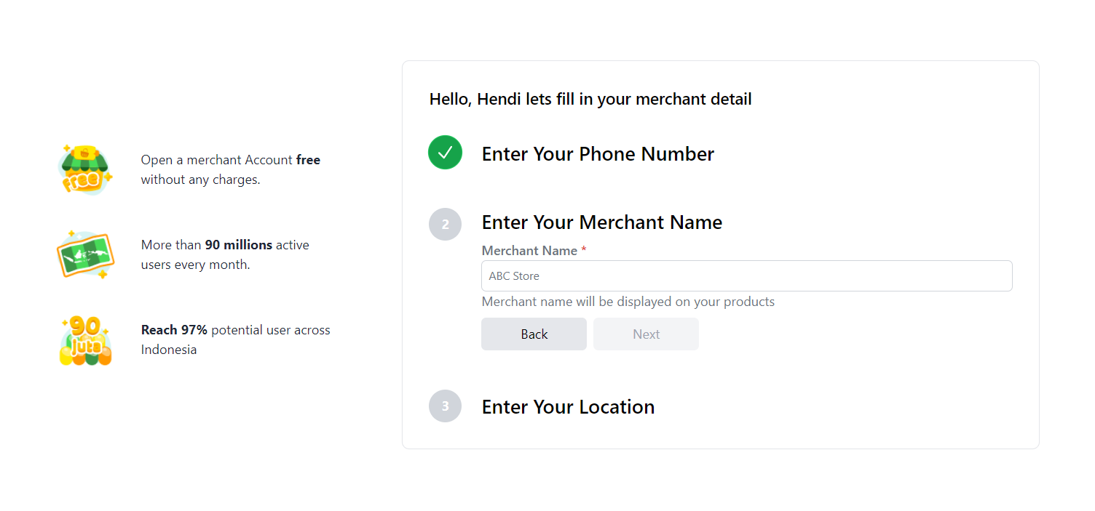

Figure 34. Create Merchant (2)

* In location step, display user’s current latitude and longitude
* In location step, display fields to input:
  + City
  + Country
  + Address
  + Postal Code
  + Notes

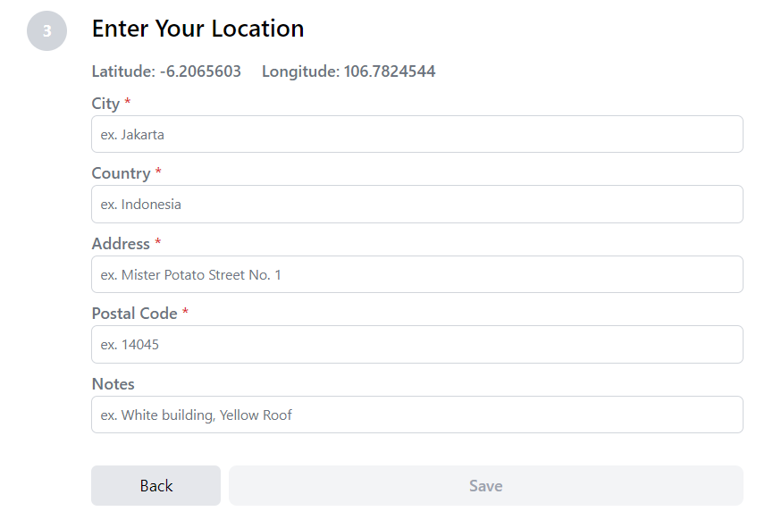

Figure 34. Create Merchant (3)

* For creating merchant, validate:
  + All fields must be filled except notes.
  + Phone number must be unique.
  + Phone number starts with 0.
  + Phone number must be 12 characters.
  + Phone number must be numeric.
  + Merchant must be between 3 and 20 characters.
  + City must be between 3 and 20 characters.
  + Country must be between 3 and 30 characters.
  + Address must be between 5 and 255 characters.
  + Postal code must be 5 digits.
  + Postal code must be numeric.
* After filling in the form, create merchant registered for the user.
* Merchant profile image is set to ... as a default.
* Merchant set this data as a default.
* **Merchant Dashboard Page**
* Merchants can view pending and shipping orders.
* The merchant dashboard page consists of 2 sections:
  + Pending Orders
  + Shipped Orders
* If there are no pending orders, display an error image and an error message.
* If there are no shipped orders, display an error image and an error message.

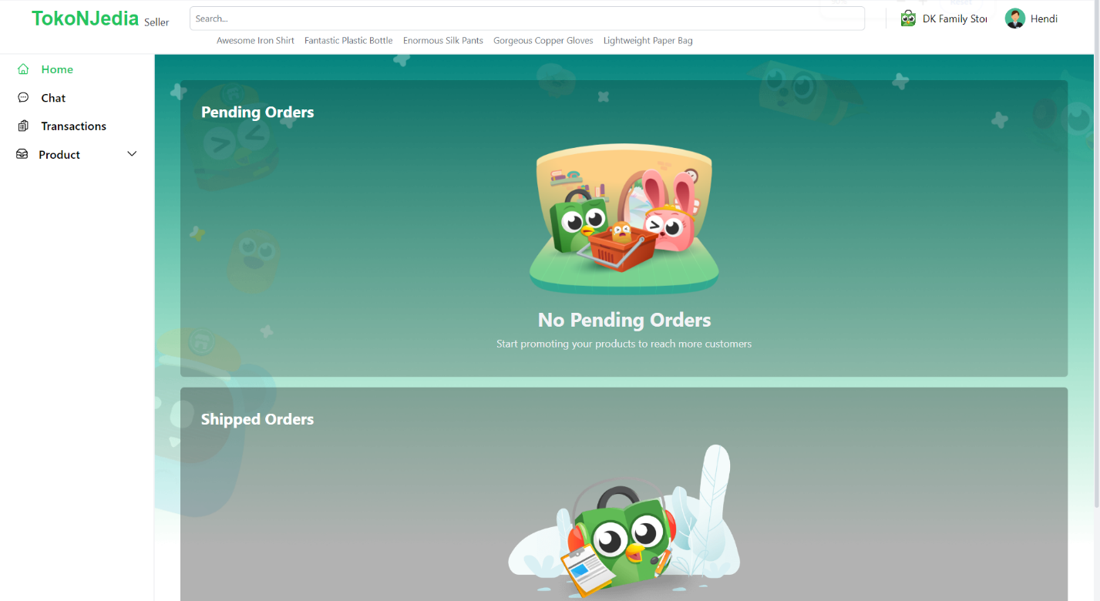

Figure 35. Merchant Dashboard (No Order & No Shipped Order)

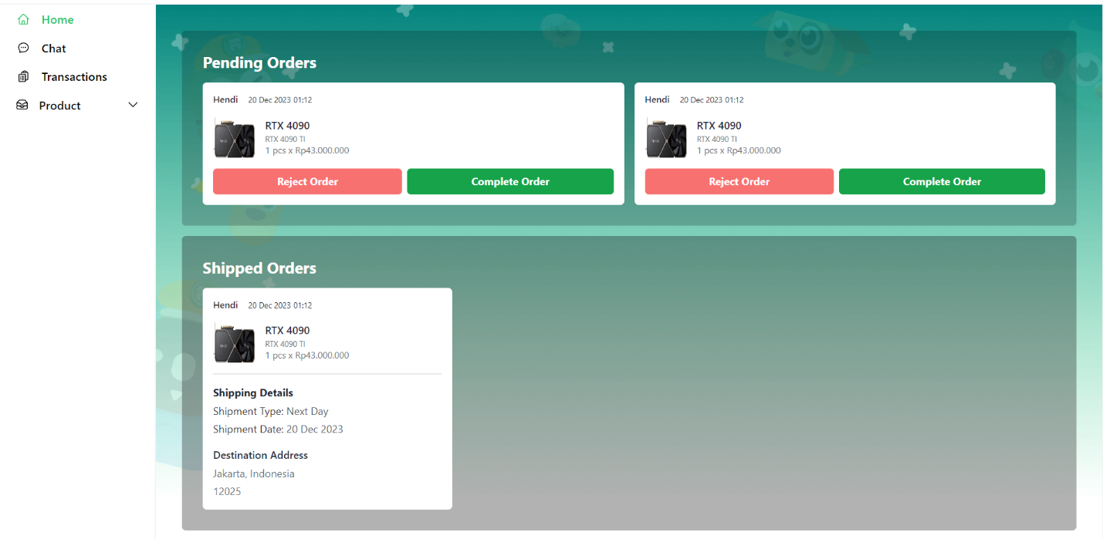

Figure 36. Merchant Dashboard (With Pending Order and Shipped Order)

* **Pending Orders**
* In this section, merchants can view pending orders and complete orders after the items are ready to ship.
* Merchant pending orders consist of:
  + Customer username
  + Transaction Date
  + Product Image
  + Product Name
  + Product Variant
  + Product Quantity
  + Product Variant Price
  + Reject Order button
  + Complete Order button
* Rejecting an order will result in the transaction status being updated to “Rejected”.
* Completing an order will result in the transaction status being updated to “Completed”.
* **Shipped Orders**
* In this section, merchants can view all shipped orders that are not yet received by the customer.
* Merchant shipped orders consist of:
  + Customer username
  + Transaction Date
  + Product Image
  + Product Name
  + Product Variant
  + Product Quantity
  + Product Variant Price
  + Shipment Type
  + Shipment Date
  + Destination Address
* **Merchant Transaction History Page**
* In this section, merchants can view all rejected and completed orders.
* In Show an error message if there are no transactions yet.
* Merchant rejected and completed order views consist of:
  + Customer username
  + Transaction Date
  + Product Image
  + Product Name
  + Product Variant
  + Product Quantity
  + Product Variant Price
  + See Review button
* Total Price

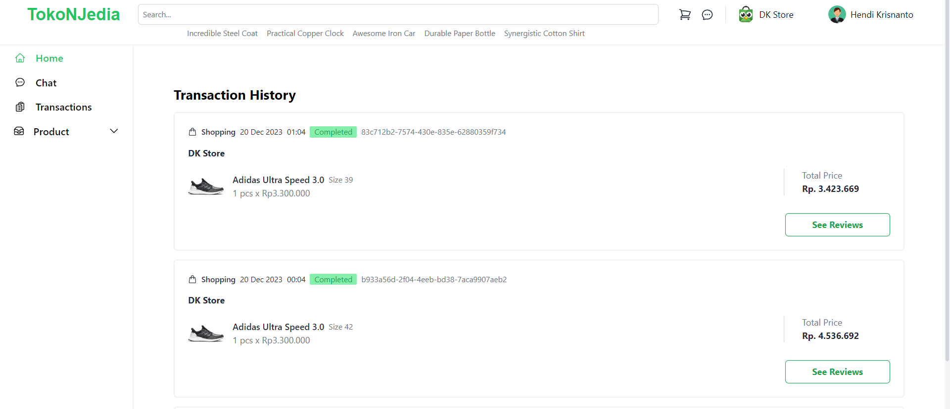

Figure 37. Merchant Transaction History

* **Add Product Page**
* In this section, merchants can fill in forms to add products to their store.
* Form consists of 3 sections:
  + Product Information:
    - Product Name Field
    - Category Dropdown (loaded from a list of all categories)

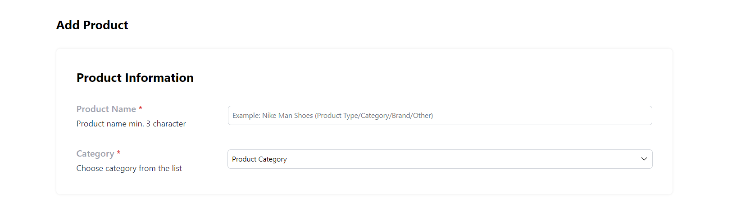

Figure 38. Product Information

* + Product Detail
    - Product Image
      * Product Image can be clicked to insert an image into the product
      * If the user cancels the product creation or refreshes the page, make sure this product image data is not saved
      * Product Image can be added more than once
      * If the added product image is clicked, the product image will be removed.
    - Condition Option
    - Product Description Text Area



Figure 39. Product Detail

* + Product Variant
    - One product must minimally have two product variants.
    - Product Variant Name.
    - Product Variant Price.
    - Product Variant Stock.
    - Product Variants can be added by clicking on the add variant button.

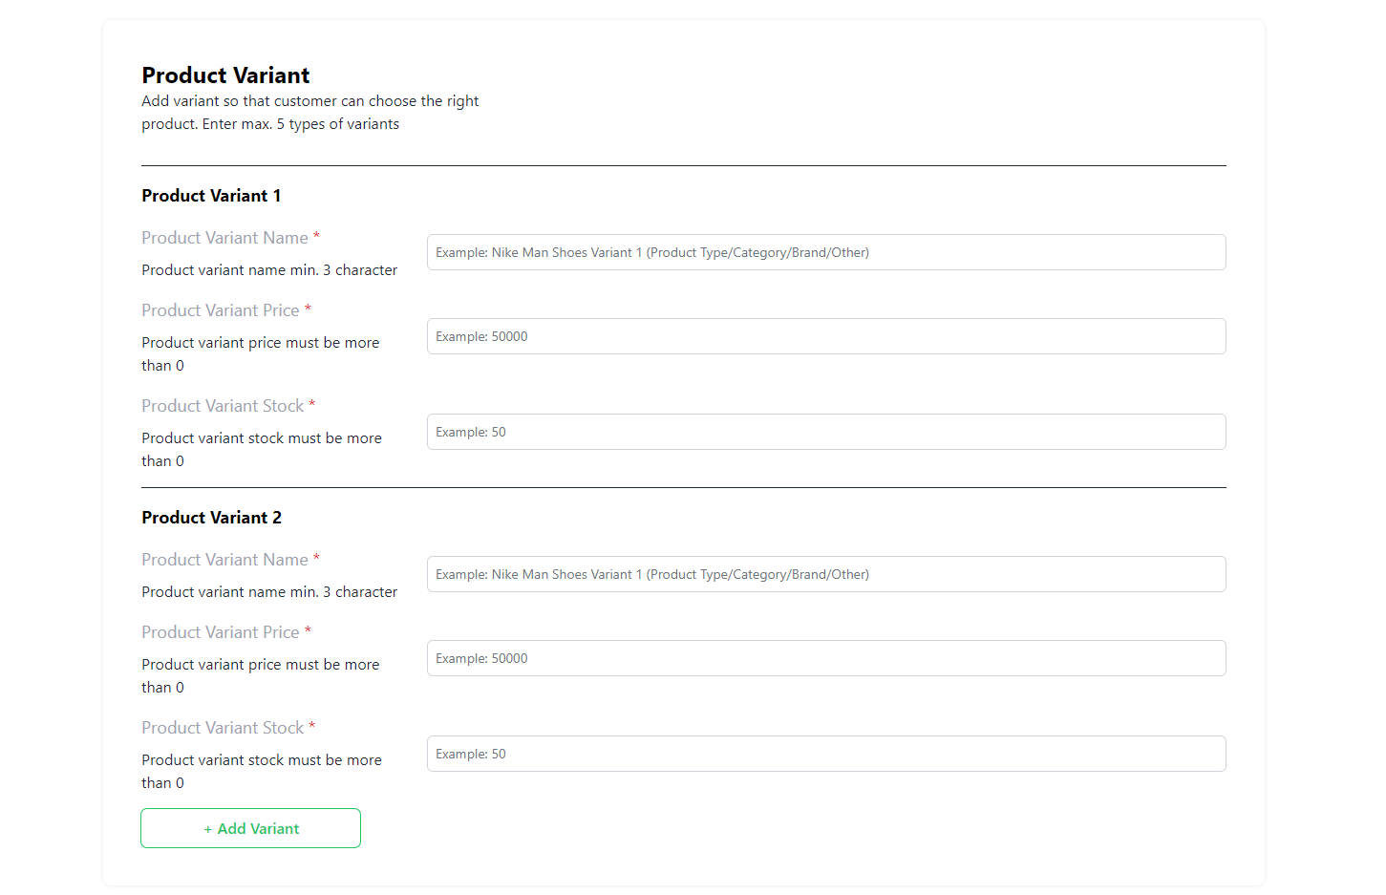

Figure 40. Product Variant

* To add a product, validate:
  + All fields must be filled.
  + Product Name must be between 3 and 50 characters.
  + At least one product image.
  + Product Description must be at least 5 characters long.
  + Product Variant Name must be between 3 and 50 characters.
  + Variant Price and stock must be a number.
  + Variant stock must be at least one.
* After successfully adding products, redirect the user to the manage product page.
* **Manage Product Page**
* Only merchants can view the Manage Product Page.
* Show error information if the merchant has no products.
* Show a button to add a product in the top right corner.
* Product List consists of:
  + Product Image
  + Product name
  + Price of the first variant
  + Stock
  + Category
  + Product Variants for each product

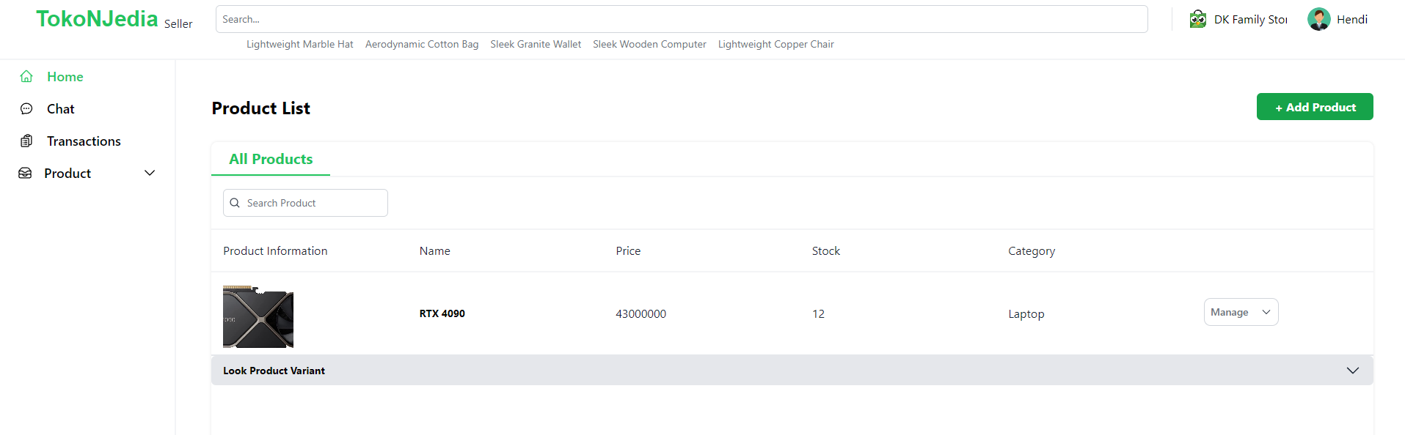

Figure 41. Manage Product Page

* **Manage Product Section**
* Manage Product button will show three options:
  + Add Variant
  + Edit
  + Delete
* Clicking on the "Add Variant" option will show the add product variant modal.
* The add variant modal consists of:
  + Product Variant Name field
  + Product Variant Price field
  + Product Variant Stock field
  + Save Button
* To add a new variant, validate:
  + Product Variant Name must be between 3 and 50 characters.
  + Variant Price and stock must be a number.
  + Variant stock must be at least one.
* If a new product variant is added, the variant will be added to the product.

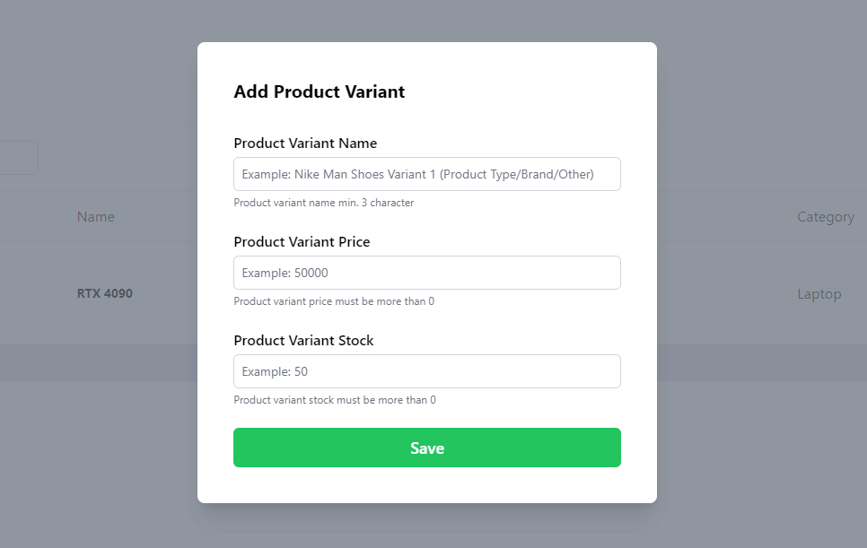

Figure 42. Add Product Variant Modal

* **Edit Product**
* Clicking on the "Edit" product button will display the edit product modal.
* The edit product variant modal consists of:
  + Product Images
  + Product Name
  + Product Category
  + Category Dropdown
  + Description Field
  + Save Button
* To edit a product, validate:
  + All fields must be filled.
  + Product Name must be between 3 and 50 characters.
  + Description must be between 5 and 200 characters.
  + At least one product image.
* Fill all the fields initially with the product information.
* Save the changes to the database if the save button is clicked.
* If the modal is closed, the changes will not be saved.

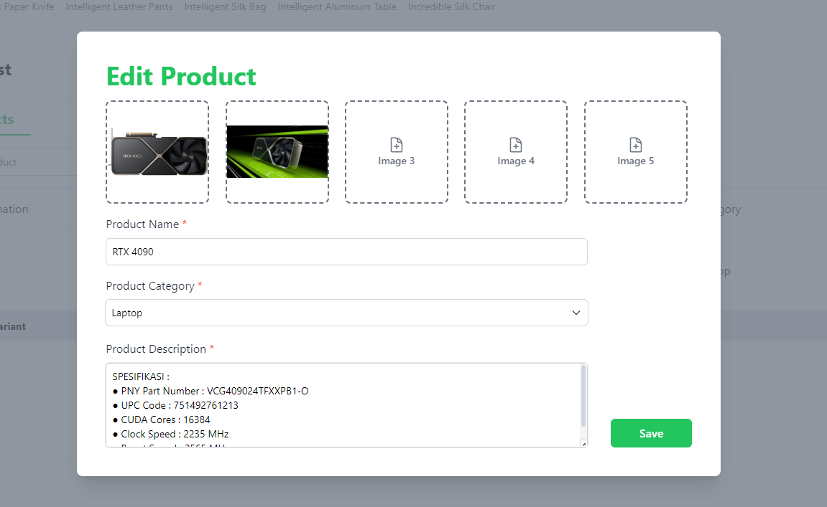

Figure 42. Edit Product Modal

* **Delete Product**
* The delete product option will delete the selected product from the product list.
* **Manage Product Variant Section**
* If product variants are clicked, show all product variant information that consists of:
  + Variant name
  + Variant price
  + Stock
  + Manage Variant Option
* If the manage product variant is clicked, manage variant will show two options:
  + Edit
  + Delete

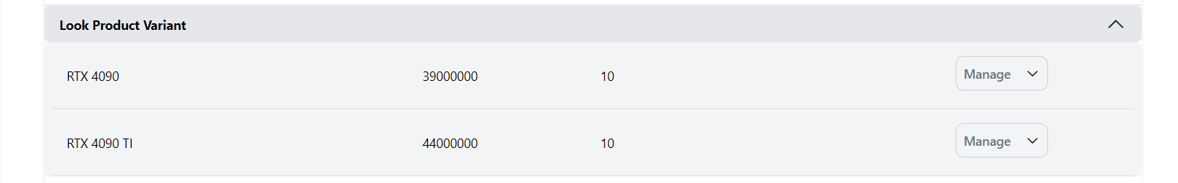

Figure 43. Manage Product Variant

* **Edit Product Variant**
* If the edit button is clicked, the edit product variant modal is displayed.
* The product variant consists of:
  + Product Variant Name field
  + Product Variant Price field
  + Product Variant Stock field
  + Cancel button
  + Save button
* Fill all the fields initially with the product variant information.
* If the cancel button is clicked, discard the changes.
* If the save button is clicked, save product information to the database.
* If the delete button is clicked, delete the product variant.

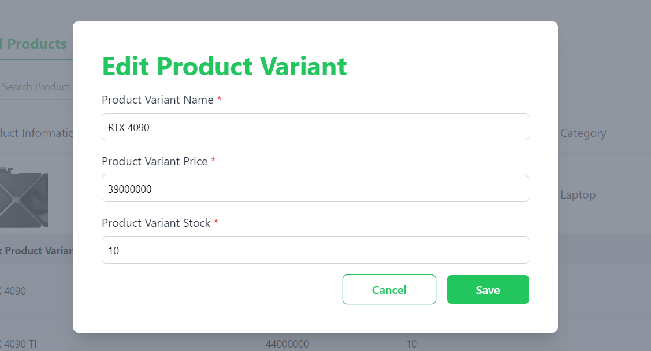

Figure 44. Edit Product Variant Modal

* **Merchant Chat Page**
* **Only merchants** can view all chat that is directed to the seller.
* If there is no chat directed to that merchant, show the error image and message.
* If the merchant chat page is clicked, load all chat rooms from the database that are directed to that user.
* Chat rooms can be searched in the search bar.

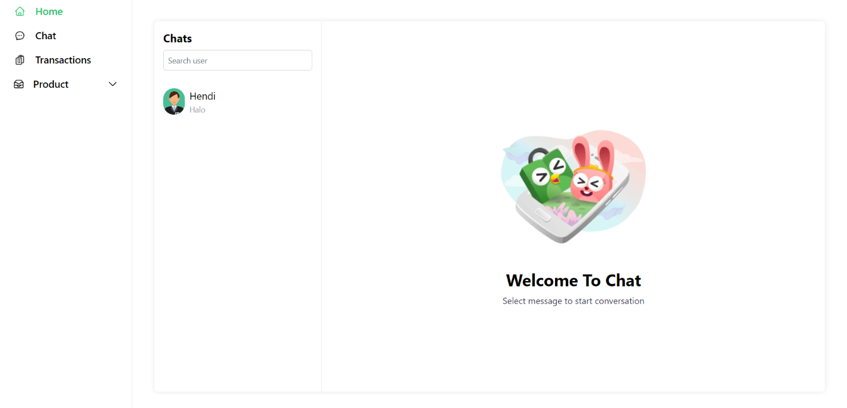

Figure 45. Merchant Chat Page

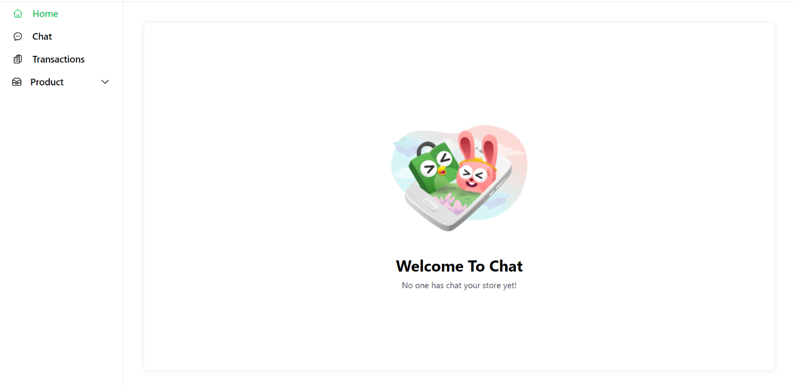

Figure 46. Merchant Chat Page (No Chat)

* **Chat Page**
* Only users can view chats that are directed to the user.
* If there is no chat directed to that user, show the error image and message.
* If the chat page is clicked, load all chat rooms from the database that are directed to that user.
* Chat rooms can be searched in the search bar.

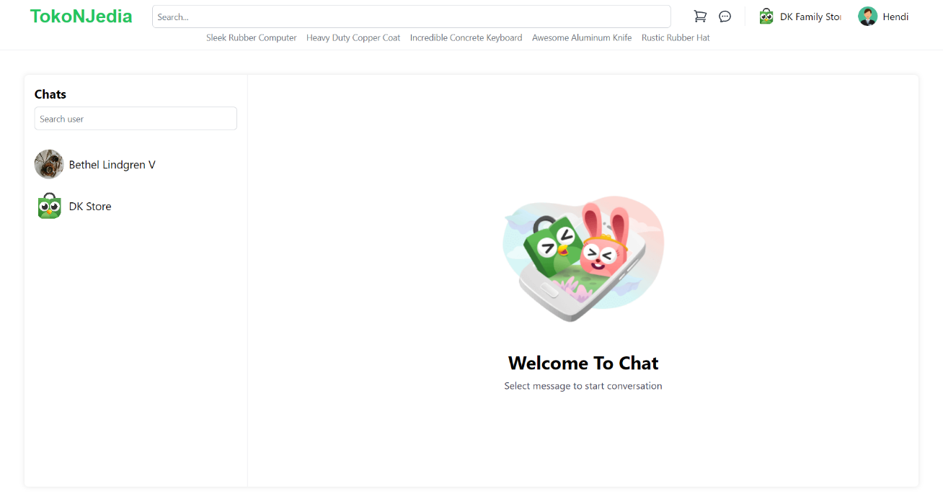

Figure 47. Chat Page

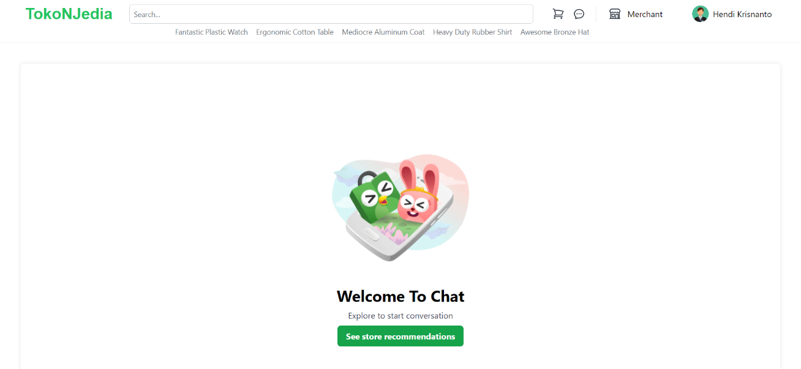

Figure 48. Chat Page (No Chat)

* **Chat Room**
* Chat room consists of:
  + The other user's profile picture
  + The other user's username
  + The last sent message.
* If the chat room is clicked, show the chat history of the merchant with the customer in the chat box.

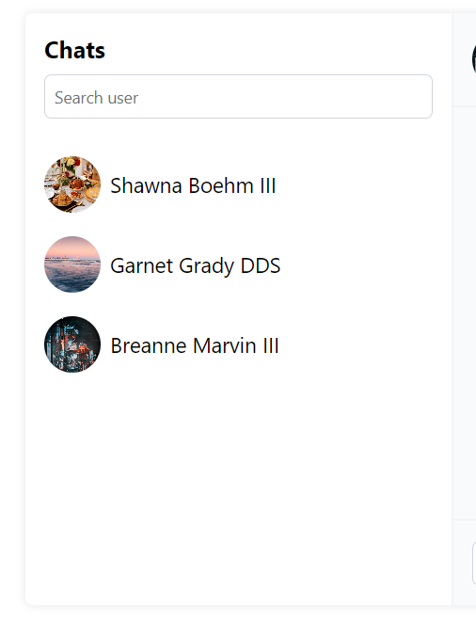

Figure 49. Chat Room

* **Chat Box Component**
* This component is used to show all the chat history of the user.
* Show all chat history using the chat bubble component.
* At the top of the chat page, there is a chat header with:
  + Profile Picture Image of the other person in the chat room
  + Username of the person in the chat room
* Chat histories from the user is aligned to the right, while the other chat history is aligned to the left.

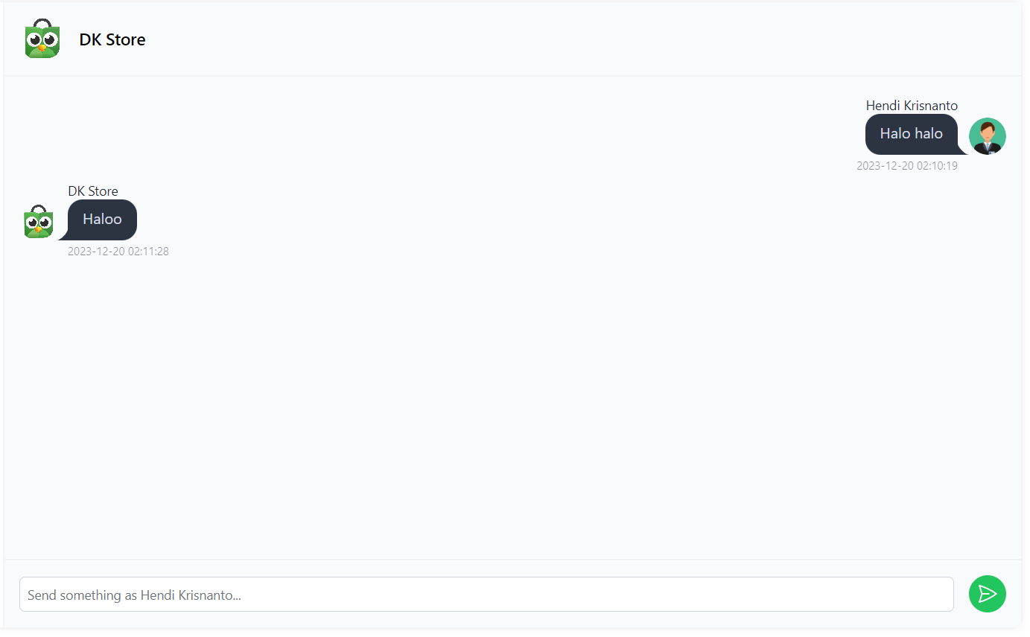

Figure 49. Chat Box Component

* **Chat Bubble**
* Chat bubble details:
  + Sender profile picture image
  + Chat message
* The chat box component has a message field and a send button to send messages.
* To send a message, validate:
  + The message field is not empty.
* **Make sure people can send and receive messages in real-time using WebSocket.**



Figure 49. Chat Bubble

* **Merchant Home Page**
* This component is visible for all user to see the store profile page.
* Merchant Homepage consists of:
  + Merchant Header
  + Home Tab
  + Product Tab

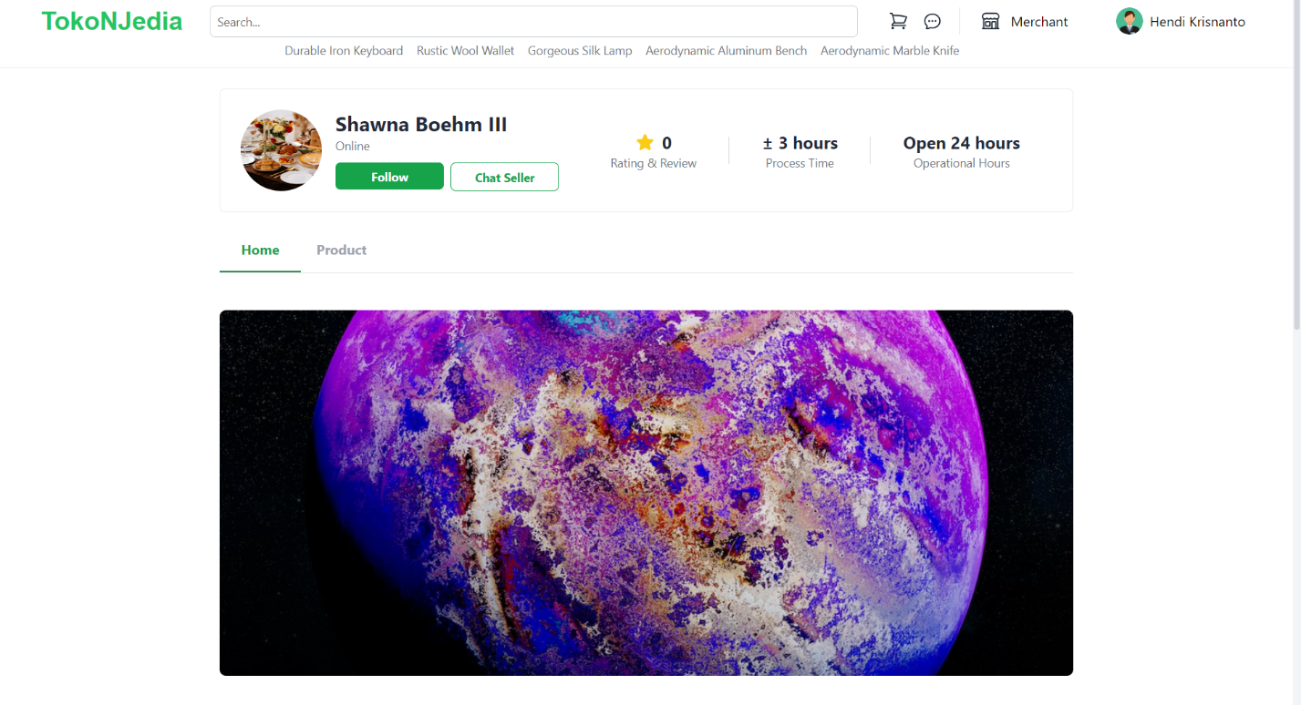

Figure 50. Merchant Home Page

* **Merchant Header**
* Merchant Header consists of:
  + Merchant Profile Image
  + Merchant Name
  + Merchant Status
  + Follow Button
  + Chat Seller Button
  + Merchant’s Average Star Rating
  + Merchant Process Time
  + Merchant Operational Hours
* Follow Merchant will add merchant to the following list and redirect user to the following merchant page.
* Chat Seller will redirect user to user chat room with the merchant, if there are not any available chat room, create new one.
* Average Rating is calculated from the average of all product ratings in the store.
* Before the footer, display merchant store information at the bottom of the page.
* Merchant Store Information consists of:
  + Merchant Store Information
  + Merchant Description
  + Merchant Open Since
  + Merchant Slogan
* Home Tab detail:
  + Home Tab displays Merchant Banner Image.
* Product Tab detail:
  + The Product Tab shows all merchant’s product in the cart format.

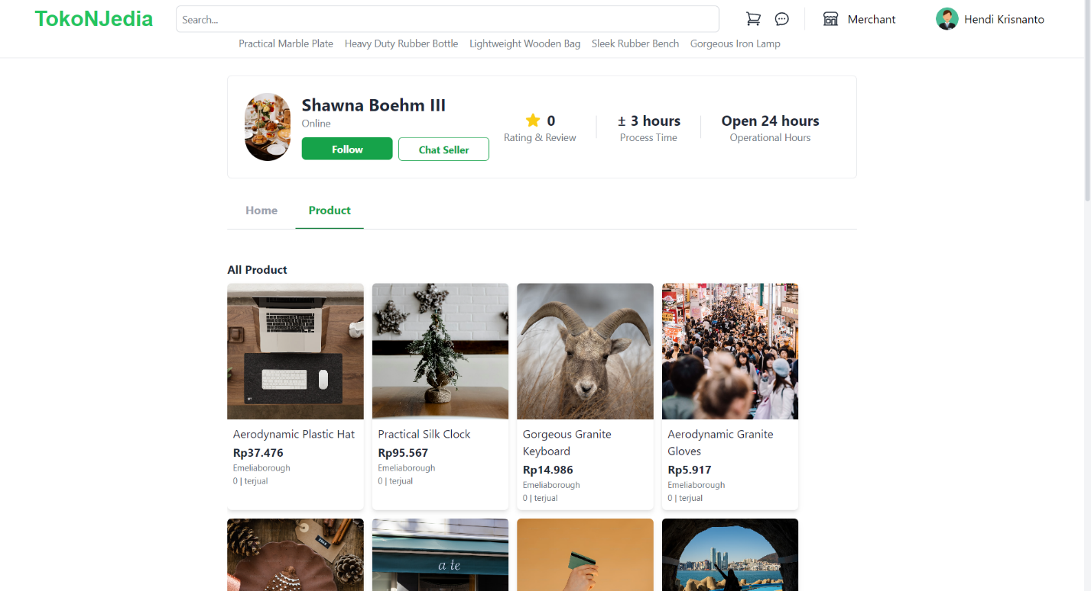

Figure 51. Merchant Product Tab

* **Custom Error Page**
* If the page is not found (user gets a 404 NOT FOUND PAGE), show the custom error page.
* If a user tries to go to a merchant page or profile page with an invalid ID, redirect the user to the custom error page.
* Error page consists of:
  + Error image
  + Error message
  + Redirect button to the home page

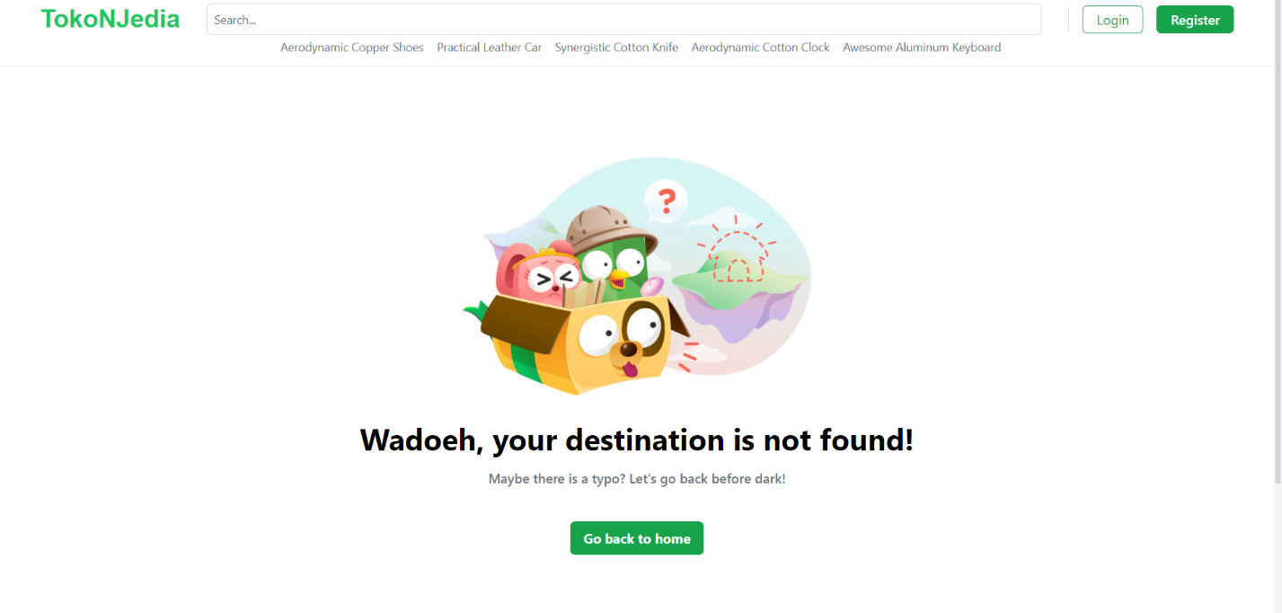

Figure 52. Custom Error Page

* **Middleware**
* Unauthenticated (Redirect to Homepage if not):
  + Login Page
  + Register Page
* Authenticated (Redirect to Login Page if not):
  + Logout
  + View Profile General Page
  + Update Username
  + Update Date of Birth
  + Update Profile Image
  + View Profile Location Page
  + Add Location
  + Delete Location
  + View items in cart
  + Add items to cart
  + Update cart
  + Delete cart
  + View Shipment Page (Checkout page)
  + View Merchant Dashboard
  + Create a Merchant Account
  + View Create Merchant Account
  + View Chat Merchant Page
  + View Merchant Transactions Page
  + View Manage Product Page
  + Add New Product
  + Delete Product Variant
  + View Merchant Homepage
  + View Merchant Products Page
  + View Chat page
  + View Profile Transactions page
  + Completing Order
  + Rejecting Order
  + Shipment Done
  + Order Top up & Bills
  + View Create Review Page
  + Create Review
  + Reply to Review
* Product Exists (Redirect to not found page if not):
  + View Product Detail
  + Delete Product
* Merchant Exists (Redirect to not found page if not):
  + View Merchant Homepage
  + View Merchant Products Page
* User has registered location (Redirect to Profile Location Page if not):
  + View Shipment Page
* User is a registered merchant (Redirect to create merchant page if not):
  + View Merchant Dashboard
  + View Chat Merchant Page
  + View Merchant Transactions Page
  + View Manage Product Page
  + Add New Product
  + Delete Product Variant
  + Reply to Review
  + Completing Order
  + Rejecting Order
* User is not a registered merchant:
  + Create a Merchant Account
  + View Create Merchant Account

Please run the EXE file to see the sample program.

## Komponen Penilaian

*Scoring Component*

|  |  |  |
| --- | --- | --- |
| No | Component | Weight |
| 1 | Component A | 50 |
| 2 | Component B | 50 |